SCHOLARSHIP LETTER

Date: 16.01.2018
Student Name: | [Student name]
Field of Study: | Management
Qualification: | Bachelor’s
Programme Name: | Entrepreneurship
Academic Period: | 2018 - 2022
Offer Letter Validity | Offer valid for the September 2018 intake only
Reference Number: | AA12345

Dear [Student name],

Congratulations! Synergy University Dubai is delighted to inform you that you have been awarded a 40% Tuition Fee Grant towards your first and last year tuition fee from Synergy University Dubai.

TUITION FEE GRANT TERMS AND CONDITIONS

- To take advantage of this Tuition Fee Grant the registration fee must be paid before 31st January 2018;
- The Tuition Fee Grant has been awarded only for the academic period of 2018 - 2022 and cannot be deferred;
- The Tuition Fee Grant only includes tuition fees and does not cover registration, visa, health insurance, books and other miscellaneous fees;
- Students awarded a Tuition Fee Grant are expected to assist Synergy University Dubai in their marketing and public relation activities as and when reasonably asked for by the University staff. Such activities might include, but are not limited to video interviews, photo sessions, student testimonials, meeting potential candidates and actively participating in other university related events.

Please note, that in case of appearance of any outstanding amounts payable during the term of award the Tuition Fee Grant stipulated above may be forfeited and become void by the resolution of Synergy University Dubai.
To confirm your acceptance of this Tuition Fee Grant please sign below and email the signed copy to the admissions office at info@synergydubai.ae.

Here's wishing you success at Synergy University Dubai!

Yours sincerely,  For and on behalf of Synergy University Dubai  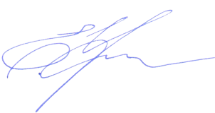  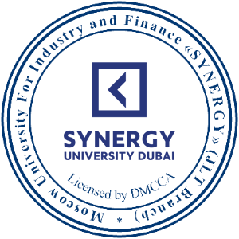  ___________________________  Elena Tselishcheva  Legal Representative | Name: ______________________________  Signature: ___________________________  Date: _______ / _______ / _____________

