Date: 21st January, 2017
To: Mr. Bobirbek Avazov
Address: Volgogradskaya st., Uzbekistan, Tashkent

Dear Mr. Bobirbek Avazov,

On behalf of Synergy University Dubai, I am pleased to congratulate you on our acceptance of your application to Bachelors in Global Economy program of September 2018 intake.

As you know, Synergy University is the oldest university in the area and we are known for accepting only the best students. Admission to our program is very competitive and we scrutinize each application carefully. During our review, we were very impressed by your academic history and achievements and feel that you would make an excellent addition to the Synergy University alumni. You have every reason to be proud of your acomplishments, and we are honored to invite you to join Synergy Community Of Leaders – faculty and students whose successes in the state and around the globe have had profound effects in our society.

We are confident you will contribute to the legacy of innovation and leadership that has defined Synergy as a premier research institution, renowned for its academic reputation. Our small, distinctive learning communities with the enrichment experiences in and out of the classroom provide an environment of intellectual challenge and exploration.

Again, we extend our congratulations on your admission to Synergy University Dubai and we hope that you find it a fulfilling and helpful experience that gets you on the road to achieving your dreams.

We wish you all the best and thank you for choosing Synergy University Dubai.

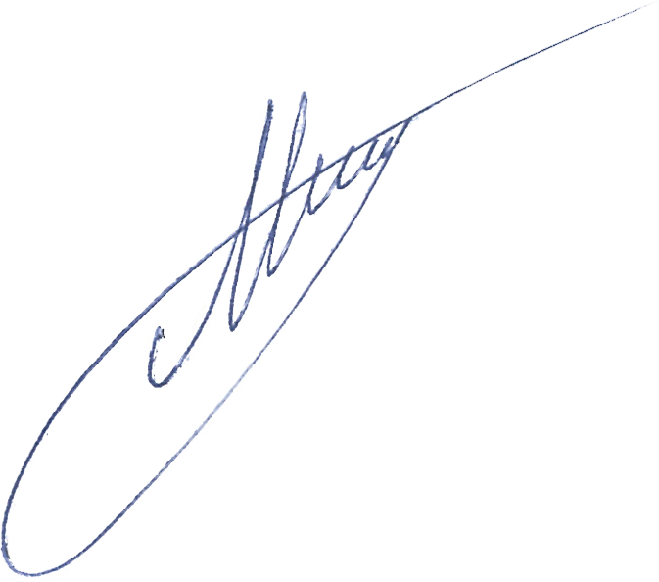
Sincerely,

_________________________
Mr. Ilya Melnichuk
Head of Admission Department
Synergy University Dubai

